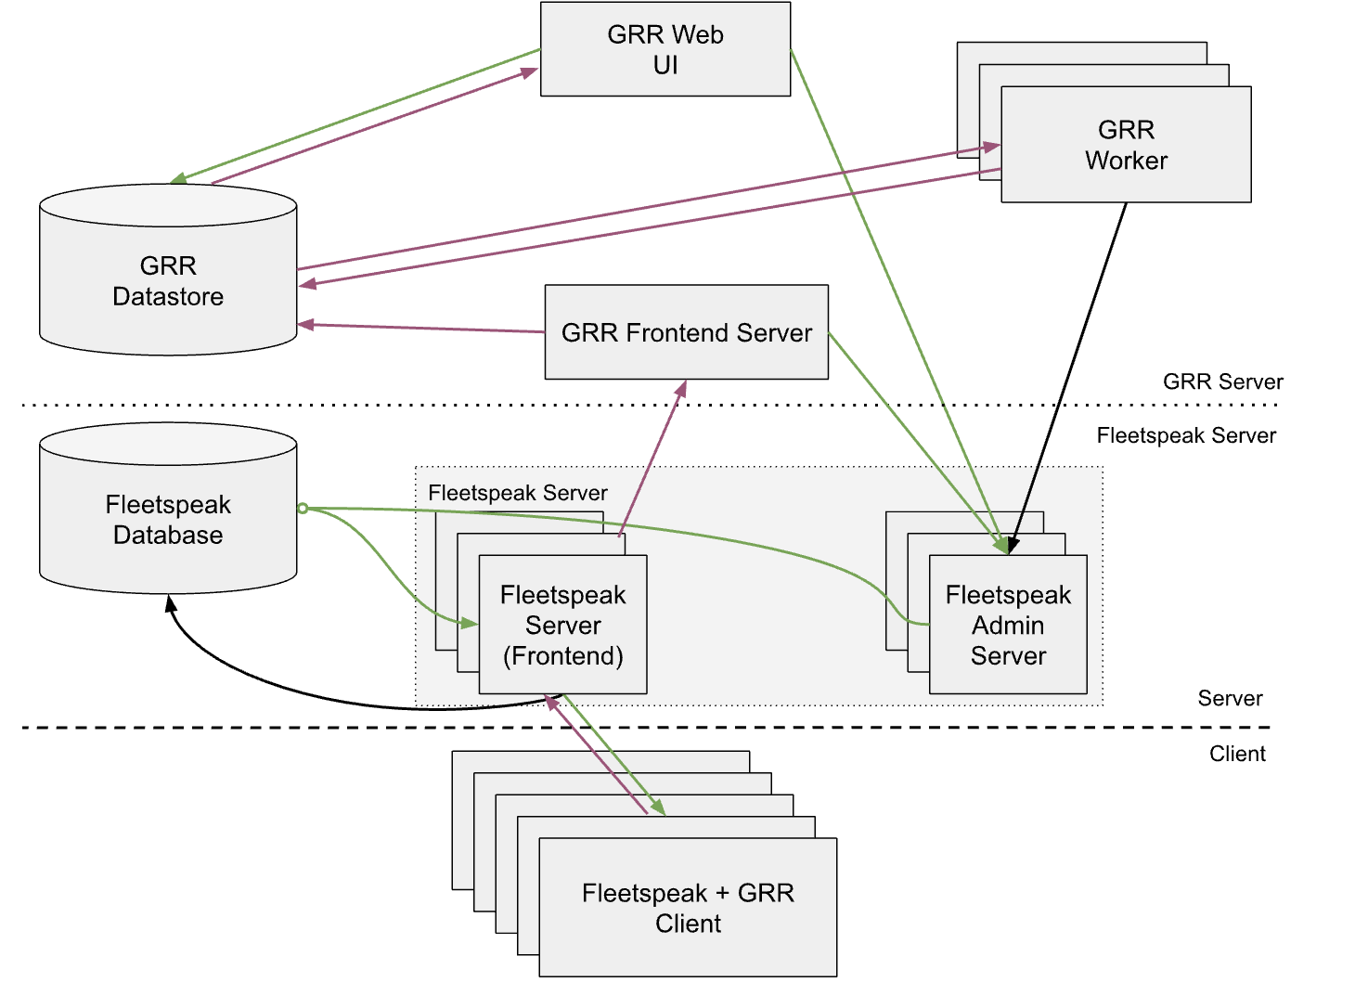

Final Netplan config (recommended)
Create / edit:
sudo nano /etc/netplan/01-static.yaml

Paste exactly this (keep spacing):
network:
version: 2
renderer: networkd
ethernets:
ens33:
dhcp4: false
addresses:
- 192.168.198.190/24
routes:
- to: default
via: 192.168.198.2
nameservers:
addresses:
- 8.8.8.8
- 1.1.1.1

Then apply permanently:
sudo netplan apply

Install MySQL server:
apt install -y mysql-server

After installation completes, you need to change the max_allowed_packet setting, otherwise GRR will have issues writing large chunks of data to the database. Put the following into /etc/mysql/my.cnf:
nano /etc/mysql/my.cnf
[mysqld]
max_allowed_packet=40M
log_bin_trust_function_creators=1

Then restart the MySQL server:
service mysql restart

You will typically want to create a new database user for GRR and give that user access an empty database that the GRR server installation will use:

mysql -u root -p
mysql> CREATE USER 'grr'@'localhost' IDENTIFIED BY 'password';

mysql> CREATE DATABASE grr;

mysql> GRANT ALL ON grr.* TO 'grr'@'localhost';

mysql> CREATE USER 'fleetspeak'@'localhost' IDENTIFIED BY 'password';

mysql> CREATE DATABASE fleetspeak;

mysql> GRANT ALL ON fleetspeak.* TO 'fleetspeak'@'localhost';

Download the latest stable server deb from:
wget https://github.com/google/grr/releases/download/v3.4.7.1-release/grr-server_3.4.7-1_amd64.deb
Install the server deb, along with its dependencies, like below:
sudo apt install -y ./grr-server_3.4.7-1_amd64.deb

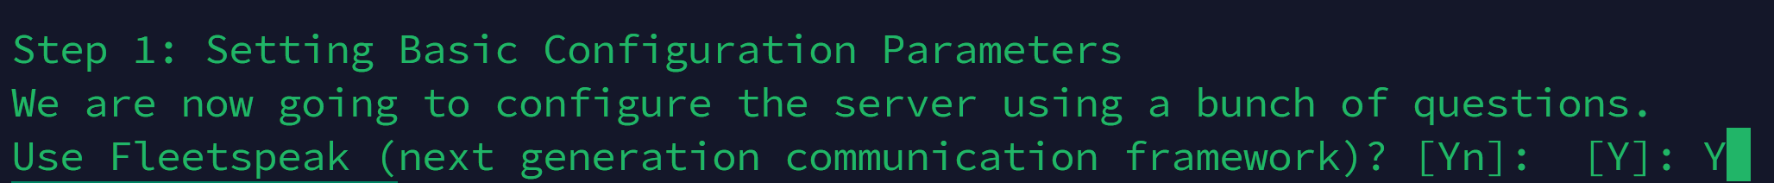
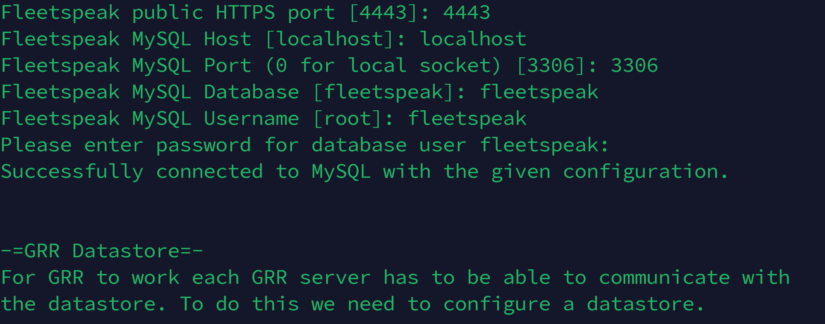
The password for fleetspeak db user is password
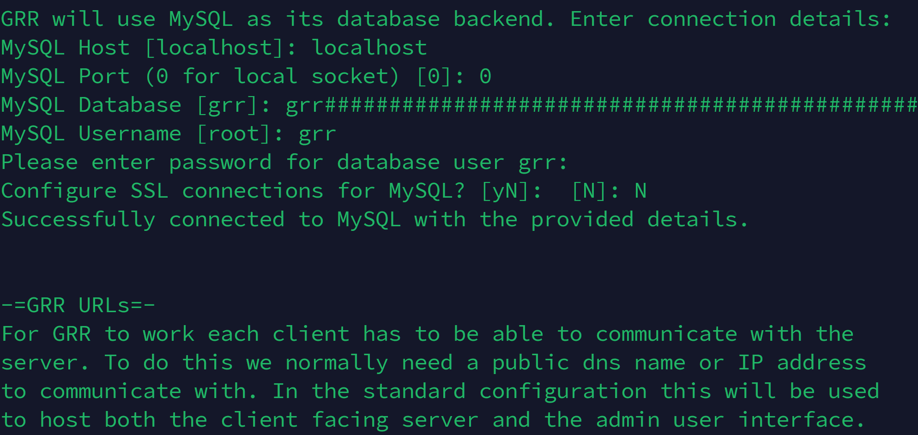
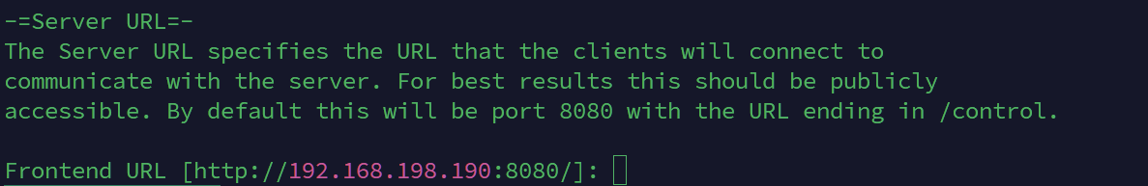
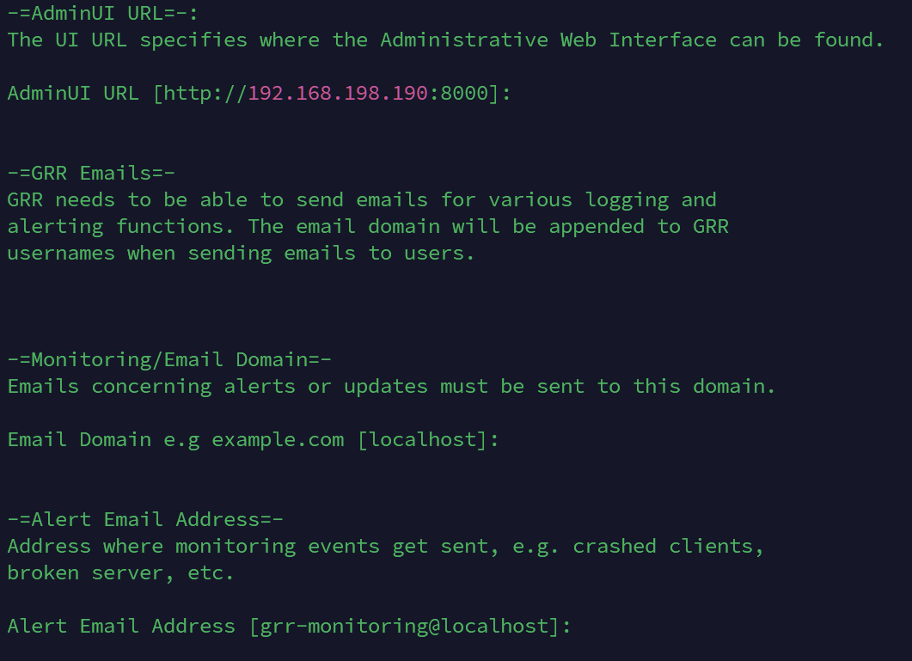
Press ENTER where email related confirmation
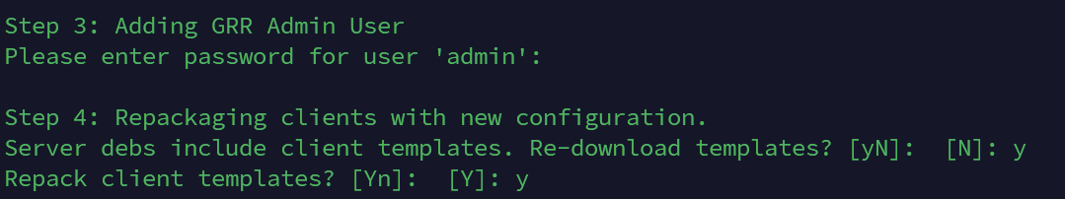
Admin password was set to “1234”

